# NFC IET UNIVERSITY,MULTAN

**LAB  REPORT**

ICT (“Information & Communication Technology-fundamental”)

For the degree of  **Bachelor**  of Science

In Computer Science

Session [2k24]

**Name                :                   Hasnat Rasool**

**Roll NO              :                     (2k24-BSCS-421)**

**Section**​**:**​ Y

**Submitted To:                         MS FAIBA HASSAN**

**Submitted By:                       Hasnat Rasool**

LAB 1

**Title: Improving Typing Skills and Understanding the Computer's Brain**

**Introduction**

In today’s digital world, typing is a fundamental skill. Whether you’re a student working on assignments, a professional typing emails, or just communicating with friends, being able to type efficiently makes a huge difference. Improving your typing speed and accuracy not only saves time but also helps prevent frustration and injuries. But typing isn't the only thing that makes computers work — the internal components of a computer, especially the Central Processing Unit (CPU), play a crucial role in making everything run smoothly. In this report, we’ll explore both how practicing typing can make you faster and more efficient, as well as take a closer look at the brain of the computer: the CPU.

### ****Section 1: Typing Practice****

#### ****1.1 What is Typing Practice?****

Typing practice involves using exercises to improve your typing speed, accuracy, and overall efficiency. Essentially, it’s all about getting comfortable with the keyboard so that your fingers can move automatically without having to think too much about where the keys are.

It’s easy to take typing for granted, but when you start practicing, you realize how much more productive you can be. Whether you’re writing emails, working on reports, or even coding, being able to type quickly and without mistakes can make a big difference.

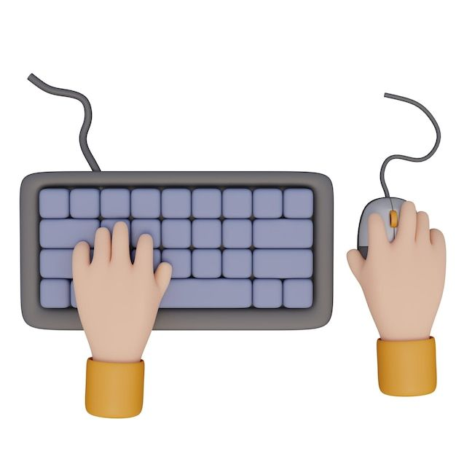

#### ****1.2 Why is Typing Practice Important?****

Being a good typist isn’t just about typing fast. It’s about typing well. If you can type quickly, but you’re making a lot of mistakes, you’re still losing time. Practicing typing helps you avoid errors, which in turn boosts your overall speed. Typing without looking at the keyboard, for example, can help you type faster and more accurately because you’re relying on muscle memory.

Improved typing skills can also reduce stress and frustration. Imagine writing an important report or responding to emails, and you’re typing slowly and making constant errors. That can be really irritating. But once you get the hang of touch typing, you’ll be amazed at how much more relaxed you feel.

#### ****1.3 How Does Typing Practice Work?****

When you practice typing, the idea is to create muscle memory in your fingers and your brain. As you practice, your fingers begin to automatically know where to go on the keyboard, so you don’t have to look down at your hands. This improves your typing speed and reduces mistakes. At first, it may feel awkward, but over time, your hands get used to the positions of the keys, and you’ll be able to type much faster and more confidently.

#### ****1.4 Tools and Techniques for Typing Practice****

There are plenty of tools out there to help you get better at typing. The most common method is **touch typing**, where you type without looking at the keyboard. This method is one of the most effective ways to improve because it teaches your fingers to go to the right keys without thinking about it.

**Typing software** like **Typing Master** is another great tool. This software has lessons and games that help you practice typing in a structured way. It even gives you feedback on how fast and accurate you're typing, which can be really motivating. Typing Master gradually increases the difficulty as you improve, so you’re always being challenged.

There are also many online websites that offer free typing tests and exercises. These tools track your progress and let you challenge yourself over time.

#### ****1.5 Why Should You Keep Practicing?****

* **Boost Your Speed**: The more you practice, the faster you'll become. In fact, you’ll be surprised at how quickly you can improve.
* **Accuracy Matters**: Speed is great, but accuracy is key. By practicing regularly, you'll make fewer mistakes, saving you time on corrections.
* **Be More Productive**: Whether you’re writing reports or chatting with colleagues, the faster and more accurately you type, the more productive you’ll be.
* **Avoid Injuries**: If you type incorrectly, it can lead to physical strain on your fingers, wrists, and hands. Proper typing technique, learned through practice, can help reduce the risk of repetitive strain injuries like carpal tunnel syndrome.

#### ****1.6 Example: Typing Master****

If you’re looking for a structured way to improve your typing, **Typing Master** is a great tool to try. This software offers a variety of lessons that gradually increase in difficulty. Whether you're just starting or looking to refine your skills, Typing Master helps by giving you lessons on everything from typing individual letters to typing full sentences. The real-time feedback is especially helpful as it shows you exactly where you’re making mistakes, which helps you focus on the areas where you need improvement. The program also includes games that make practicing typing fun.

### ****Section 2: Internal Components of a Computer****

#### ****2.1 The Role of the CPU****

Now that we’ve covered typing practice, let’s dive into the inner workings of a computer. A computer is made up of several key components, and one of the most important is the **Central Processing Unit (CPU)**. The CPU is essentially the “brain” of the computer. It interprets and executes instructions, making everything you do on your computer possible.

Think of the CPU as the control center. When you open a program or run a task, it’s the CPU that’s carrying out the instructions to make it happen. The CPU’s ability to process data quickly determines how fast your computer works.

#### ****2.2 What Does the CPU Do?****

The CPU is responsible for executing instructions, performing calculations, and making decisions that allow the computer to carry out tasks. These tasks include everything from running a word processor to playing a video or browsing the web. The CPU handles the flow of data to and from various parts of the computer and makes sure everything happens in the right sequence.

#### ****2.3 Key Components of the CPU****

Inside the CPU, there are a few essential parts that work together to perform its duties:

**Control Unit (CU)**: This part of the CPU directs all the operations and makes sure instructions are executed in the right order. It tells the rest of the CPU what to do next, and ensures the computer stays on track.

**Arithmetic Logic Unit (ALU)**: The ALU handles all the math and logical operations, like adding numbers or comparing values. Whenever a program needs to calculate something, the ALU does the work.

**Registers**: These are small storage spaces inside the CPU that hold data temporarily while the CPU is processing it. Think of them as quick-access areas where the CPU keeps data it needs right away.

**Cache**: The CPU also has a small, ultra-fast memory called **cache**. This stores frequently accessed data to speed up processing, so the CPU doesn’t have to go to the main memory every time it needs something.

#### ****2.4 How the CPU Works****

When you run a program, the CPU begins by fetching instructions from memory. These instructions are decoded and processed by the ALU and CU. If there’s any math or logic involved, the ALU handles it, and then the CPU sends the results to memory or an output device, like your screen. The CPU is constantly doing this behind the scenes, allowing your computer to run smoothly.

### ****Section 3: Why the CPU is Crucial for Performance****

The CPU has a huge impact on how fast and efficiently your computer works. If you’re using a computer with a fast, powerful CPU, everything you do — from opening files to playing games — will happen much quicker. But if your CPU is slow or outdated, even simple tasks can feel sluggish.

One thing that affects CPU performance is the **number of cores** it has. Modern CPUs often have multiple cores, which allows them to handle several tasks at once, making them great at multitasking. This is especially useful when you have multiple programs running or when you’re doing something resource-heavy like video editing.

### ****Conclusion****

Improving your typing skills and understanding the computer’s internal components are both essential in today’s tech-driven world. Typing practice can make you more efficient, accurate, and comfortable with using the keyboard, while understanding how your computer’s CPU works can give you a deeper appreciation for the technology you use every day. By investing time into improving your typing and learning about the computer’s brain, you can enhance your productivity and be better equipped to tackle both everyday tasks and more complex challenges.

This version presents the same information, but in a more approachable and relatable tone, helping make the technical content easier to understand and more engaging.

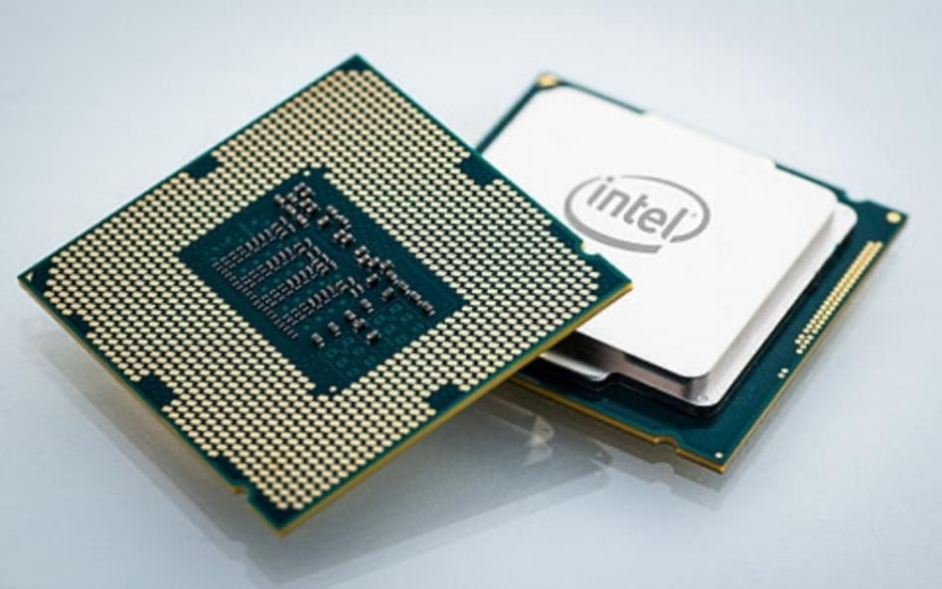

Certainly! Here’s a more approachable and conversational version of the content:

**Title: Key Internal Components of a Computer and Their Functions**

**Introduction**

In today's digital world, computers are essential tools for almost everything we do. Whether we're working, studying, or simply browsing the internet, the hardware inside a computer plays a key role in ensuring everything runs smoothly. The motherboard, power supply unit (PSU), and memory (RAM) are three of the most crucial components that allow a computer to function properly. Each one of these parts has its own unique role, and together, they help power the computer, process information, and keep things running efficiently. In this report, we’ll take a closer look at these components, how they work, and why they’re so important.

### ****Section 1: The Motherboard****

#### ****1.1 What is the Motherboard?****

Think of the motherboard as the main foundation of a computer. It’s a large circuit board that connects all the different parts of the system, like the processor (CPU), memory (RAM), and storage devices (hard drive or SSD). Without it, all these components wouldn’t be able to communicate with each other.

The motherboard is like the central nervous system of your computer, making sure all the pieces work together smoothly. It helps transfer data between the processor, memory, storage devices, and even expansion cards like your graphics card or sound card.

#### ****1.2 Key Parts of the Motherboard****

**CPU Socket**: The CPU is the “brain” of the computer, and it’s installed onto the motherboard in a special socket. This is where the processor connects to the motherboard, allowing it to communicate with other components.

**RAM Slots**: The motherboard has slots where you can install RAM (Random Access Memory). RAM is used by the CPU to store data that’s being processed right now. More RAM means your computer can handle more tasks at once without slowing down.

**Storage Connectors**: These are the ports that allow you to connect storage devices, like hard drives or SSDs, to the motherboard. They allow the motherboard to communicate with these devices to access your files and programs.

**Expansion Slots**: These slots are where you can add additional components, like a graphics card or network card. They allow your computer to be upgraded and customized with new features.

**Chipset**: The chipset is essentially the manager of the motherboard. It decides what components are compatible with the motherboard and helps data move around efficiently.

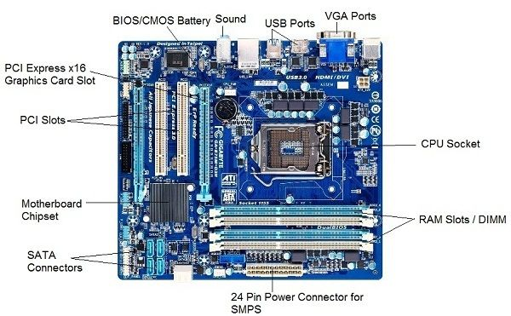

#### ****1.3 Why the Motherboard Matters****

The motherboard is crucial because it holds everything together and facilitates communication between all the parts of the computer. A well-designed motherboard with the right ports and capabilities can significantly boost your computer’s performance. Without it, none of the components would be able to interact with each other.

### ****Section 2: Power Supply Unit (PSU)****

#### ****2.1 What is the Power Supply Unit (PSU)?****

The power supply unit (PSU) is another essential part of the computer. Its job is to convert the power from your home’s electrical outlet into the kind of power that the computer needs to run. In simple terms, it’s the part of the computer that gives all the components the electricity they need to function.

#### ****2.2 How the PSU Works****

When you plug your computer into a power outlet, the PSU takes the alternating current (AC) electricity from the wall and changes it into direct current (DC) electricity. DC power is what the computer’s components, like the CPU, RAM, and hard drive, need to run.

The PSU doesn’t just provide electricity—it also provides different voltages that are needed by different parts of the computer. For example, the motherboard might need 12V, while your RAM or storage might need 5V or 3.3V. The PSU ensures the right voltage goes to the right components.

#### ****2.3 Key Features of the PSU****

**Voltage and Wattage**: The PSU provides different voltages to various components, ensuring that they get the power they need. The wattage of the PSU tells you how much total power it can supply. A higher wattage PSU is necessary for powerful computers with high-performance parts like gaming PCs or workstations.

**Efficiency**: The efficiency of the PSU is important because an inefficient power supply wastes energy, generating excess heat and costing you more in electricity. A high-efficiency PSU uses energy more effectively, saving you money and reducing the computer’s environmental impact.

**Modular vs. Non-Modular PSUs**: There are two types of PSUs: modular and non-modular. Modular PSUs allow you to attach only the cables you need, making cable management easier and your computer’s interior less cluttered. Non-modular PSUs come with all cables permanently attached, which can sometimes make managing cables a bit more challenging.

#### ****2.4 Why the PSU is Crucial****

#### The PSU is what keeps your computer running, and without a good one, your computer won’t have the stable power it needs to function. A low-quality or underpowered PSU can cause crashes, instability, or even damage your components. Therefore, it’s important to choose a reliable PSU that provides the right amount of power and is built to last.

### ****Section 3: Memory (RAM)****

#### ****3.1 What is RAM?****

RAM (Random Access Memory) is like your computer’s short-term memory. It stores data that the CPU is currently using or processing. Whenever you open a program or a file, it gets loaded into RAM, allowing the CPU to quickly access and work with it.

RAM is a type of “volatile” memory, meaning that when you turn off the computer, all the data stored in RAM is lost. Unlike storage devices (like hard drives or SSDs), which retain data even when the computer is powered off, RAM only works when the system is running.

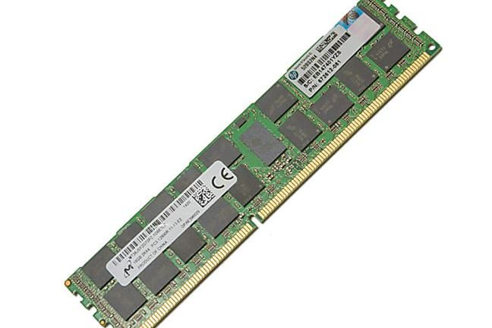

#### ****3.2 How RAM Works****

When you run a program or open a file, the data is loaded from the hard drive (or SSD) into RAM, which is much faster. The CPU then pulls data from RAM as it works on the task at hand. If you have more RAM, your computer can handle more tasks simultaneously without slowing down.

For example, if you’re running multiple programs or have many browser tabs open, the CPU needs to access all that data quickly. More RAM allows the CPU to retrieve data faster, improving overall system performance.

#### ****3.3 Types of RAM****

**DRAM (Dynamic RAM)**: This is the most common type of RAM used in modern computers. DRAM needs to be refreshed constantly to retain data, but it’s cost-effective and sufficient for most users.

**SRAM (Static RAM)**: SRAM is faster than DRAM, but it’s also more expensive. It’s typically used in smaller amounts, like in the CPU cache, where speed is critical.

**DDR RAM (Double Data Rate)**: DDR is a type of DRAM used in most modern computers. It has different generations (DDR2, DDR3, DDR4) that offer progressively faster speeds and better performance. DDR4 is the current standard for most systems.

#### ****3.4 Why RAM is Important****

RAM plays a big role in how fast and responsive your computer is. More RAM means you can run more programs simultaneously without performance slowing down. If your computer doesn’t have enough RAM, it will rely on slower storage devices, like your hard drive or SSD, to make up for the lack of memory. This can make the system feel sluggish, especially when running more demanding tasks like video editing or gaming.

**Conclusion**

In conclusion, the motherboard, power supply unit (PSU), and RAM are all essential components that work together to make your computer function properly. The motherboard connects everything and ensures the parts can communicate, while the PSU provides the necessary power. RAM helps your computer run faster by allowing quick access to the data the CPU is processing. Together, these parts form the foundation of your computer, and understanding how they work can help you make better decisions when choosing, building, or upgrading a system.

**LAB 2**

**Title: Step-by-Step Guide to Installing Windows on Your PC**

**Introduction**

Installing an operating system like Windows is a fundamental skill for anyone working with computers, whether you're setting up a brand-new machine or reinstalling Windows to fix issues. The process may seem daunting, but it’s actually straightforward if you break it down into manageable steps. This guide will walk you through the process of installing Windows, explaining why each step matters and what you can expect along the way. By the end, you’ll have a fully functional system ready for use, and you’ll feel confident in handling the installation yourself.

### ****Section 1: Preparing for Installation****

Before you jump into the installation process, there are a few things to take care of. Preparation is key to ensuring a smooth experience.

#### ****1.1 Back Up Your Data****

The first step before installing Windows is to back up your important files. Whether you’re installing a fresh copy of Windows or upgrading an existing one, there’s always a risk of losing your data. You can’t be too cautious! Make sure to back up everything—photos, documents, videos, and any other important files—onto an external hard drive, USB flash drive, or even cloud storage. This way, you won’t risk losing any work, personal files, or memories.

It’s also a good idea to back up settings or configurations for any software you use regularly. For example, if you’re using programs like Photoshop or any coding environments, make sure your settings are stored safely, too.

#### ****1.2 Create a Bootable USB or DVD****

To install Windows, you’ll need a bootable USB drive or DVD with the Windows installer. Here’s how to get it ready:

**Download the Windows ISO File**: Go to Microsoft’s official website and download the appropriate Windows ISO file (e.g., Windows 10 or Windows 11). Make sure you choose the right version for your system.

**Prepare the USB or DVD**: If you're using a USB, make sure it has at least 8GB of free space. You can use the **Windows Media Creation Tool** to create the bootable USB. If you're using a DVD, just burn the ISO file onto a blank disk.

**Check the Bootable Media**: After you create the bootable media, it’s a good idea to test it by plugging the USB drive into a computer and rebooting it. The computer should boot from the USB or DVD, which will help confirm everything is set up correctly.

#### ****1.3 Check System Requirements****

Before you begin the installation process, make sure your PC meets the minimum system requirements for the version of Windows you're installing. This is important because Windows needs certain hardware to run efficiently. Here’s what you should check:

* **Processor**: At least 1 GHz or faster with two or more cores.
* **RAM**: 4 GB or more (8 GB is recommended for smoother performance).
* **Storage**: You’ll need at least 64 GB of free space on your hard drive or SSD.
* **Graphics**: Direct X 12 compatible graphics device or integrated graphics.
* **Firmware**: UEFI firmware (instead of legacy BIOS) for faster start-up and security.

Check your computer’s specifications using built-in system tools or the manufacturer’s website to make sure everything is compatible with the Windows version you want to install.

### ****Section 2: Booting from Installation Media****

Once you’ve prepared everything, it’s time to get the installation process underway.

#### ****2.1 Insert the USB or DVD and Restart Your PC****

With your bootable USB or DVD ready, insert it into your PC and restart your computer. This is when the fun begins! However, before Windows can install, your PC needs to know to boot from the external media (USB or DVD) instead of your current operating system.

#### ****2.2 Access BIOS/UEFI Settings****

To change the boot order, you’ll need to access your PC’s BIOS/UEFI settings. These settings control how your PC boots up, and you’ll use this menu to tell your computer to boot from the USB or DVD:

1. **Turn on or restart your PC**.
2. As your PC is starting up, press the key to enter BIOS/UEFI settings. Common keys are **F2**, **F12**, **Esc**, or **Delete** (it should appear on the screen during start-up).
3. Once in the BIOS/UEFI, navigate to the **Boot Options** or **Boot Order** section. You’ll be able to select the USB or DVD as the primary boot device.

After you’ve made the changes, save your settings and exit the BIOS/UEFI. Your PC will restart and boot directly from the Windows installation media.

### ****Section 3: Starting the Installation****

Now that your system is set up to boot from the installation media, let’s walk through the steps that will get you into the Windows setup process.

#### ****3.1 Select Language, Time, and Keyboard Preferences****

When your PC boots from the installation media, you’ll see the Windows Setup screen. The first thing you’ll need to do is select your language, time zone, and keyboard layout. Don’t worry; you can always change these settings later, but this helps the installation process begin in your preferred language and format.

Click **Next** to continue.

#### ****3.2 Enter the Product Key (If You Have One)****

In the next screen, you’ll be asked to enter a **product key** for Windows. This is a 25-character code that you should have received when you purchased Windows. If you’re reinstalling Windows on a device that already had it activated, you may not need to enter a key, as Windows will automatically detect it.

If you don’t have a product key or don’t want to enter it at this stage, you can click **I don’t have a product key** and proceed. Windows will allow you to install the system, but you’ll need to activate it later.

#### ****3.3 Accept License Terms****

Before you proceed, you’ll need to agree to Microsoft’s End User License Agreement (EULA). This agreement outlines the terms of use for the operating system. Read through it (or just scroll to the bottom) and click **Accept** to move on.

### ****Section 4: Choosing the Installation Type****

At this point, you’ll be given two options: **Upgrade** or **Custom**.

#### ****4.1 Upgrade Installation (Retain Files and Settings)****

If you're upgrading from a previous version of Windows, choosing **Upgrade** will keep your files, settings, and programs intact. This option is great if you want to upgrade to a newer version of Windows without losing your current data.

However, it’s still a good idea to back up your data before upgrading just in case anything goes wrong.

#### ****4.2 Custom Installation (Clean Install)****

If you’re looking to start fresh (or if you’re reinstalling Windows due to issues with your current system), a **Custom** installation is the best option. This option will wipe your hard drive and install a clean version of Windows, so make sure all your data is backed up first.

During this step, you’ll also be asked to choose where to install Windows. You can select a partition or format an existing one to clean the drive before installation. If you’re not sure, you can let the installer handle partitioning automatically.

Once you’ve selected the partition, click **Next** to begin the installation.

### ****Section 5: Installing Windows****

#### ****5.1 Copying Files and Installing Windows****

The system will now copy files and install Windows. This process may take a while, depending on your system’s speed. You might see progress bars or messages about the installation stages—just be patient.

Your PC will restart several times during the process, and that’s perfectly normal. After the initial file copying, Windows will begin configuring settings and finalizing the installation.

#### ****5.2 Reboots During Installation****

It’s important to remember that the installation process may require several reboots. Windows will restart the system and continue installing in the background, but don’t worry—it’s not frozen. Just let it run its course, and soon you’ll be able to move on to the next step.

### ****Section 6: Finalizing the Setup****

Once Windows finishes installing, you’ll need to set up your preferences and complete a few final configurations.

#### ****6.1 Create a User Account and Set Preferences****

You’ll be prompted to create a user account and set up a password. This is the account you’ll use to log into Windows, so make sure you choose something secure.

You’ll also be asked to customize some privacy settings, like whether or not to allow Windows to use location services, send diagnostic data to Microsoft, and use personalized ads. Feel free to customize these based on your preferences.

#### ****6.2 Sign In with a Microsoft Account (Optional)****

Windows gives you the option to sign in with a **Microsoft Account**. Doing so lets you sync settings, files, and apps across devices. If you prefer not to link your PC to the cloud, you can create a **local account** instead.

#### ****6.3 Final Configuration****

Once you've completed the setup, Windows will finish configuring your system. It may take a few minutes for everything to be ready, but after that, you’ll be presented with the desktop, and your system will be fully operational.

**Conclusion**

And just like that, you’ve installed Windows! The process may seem a little intimidating at first, but once you break it down step by step, it’s a straightforward task. From backing up your data to customizing your settings, every

\窗体顶端

窗体底端

**Title: How to Assemble a CPU and Build a Computer from Scratch**

**Introduction**

Building your own computer can be an exciting and rewarding experience. Whether you’re putting together a machine for gaming, work, or study, the process teaches you how each part of the system works together to make everything run smoothly. This guide walks you through the step-by-step process of installing the CPU, applying thermal paste, securing the CPU cooler, installing the RAM, and setting up the motherboard. I’ll also explain how to connect the power supply unit (PSU) and all the other essential components to make sure your computer runs properly from the start.

### ****1. Install the CPU****

The CPU (Central Processing Unit) is often called the "brain" of the computer, and for good reason—it processes all the instructions that make everything work. Installing the CPU is one of the first steps in building your computer, and it’s important to do it carefully.

#### ****1.1 Open the CPU Socket****

The CPU socket is where the processor will sit on the motherboard. To get started, locate the CPU socket, which is usually near the center of the motherboard. You’ll notice that most motherboards have a protective cover or latch to keep the socket safe from damage.

Gently release the latch or lever that holds the socket cover in place. Once it’s open, you’ll have access to the socket where you’ll install the CPU.

#### ****1.2 Align and Place the CPU****

Your CPU will have a small marking on one corner, usually a gold triangle or a specific shape. This marking must align with a similar one on the CPU socket. This ensures that the CPU is installed correctly and prevents you from damaging the pins or socket.

Carefully lower the CPU into the socket, ensuring it fits snugly without forcing it. If it doesn’t slide in easily, double-check the alignment. The CPU should fall naturally into place when properly aligned.

#### ****1.3 Secure the CPU****

Once the CPU is seated correctly, lower the latch or lever to secure it in place. This step locks the CPU into the socket, ensuring a stable connection with the motherboard. Don’t worry about using too much force; just make sure the lever clicks into place.

### ****2. Apply Thermal Paste****

Thermal paste is an essential component that helps transfer heat from the CPU to the cooler, keeping it at a safe operating temperature. If your cooler doesn’t come with thermal paste pre-applied, you’ll need to apply it yourself.

#### ****2.1 Apply a Pea-Sized Amount****

Thermal paste should be applied in a small amount—usually a pea-sized drop in the center of the CPU. If you use too much paste, it can overflow when you attach the cooler, which is unnecessary. If you use too little, it might not provide enough coverage, leading to poor heat dissipation.

Don’t worry too much about spreading the paste; once the cooler is installed, it will naturally spread evenly across the surface.

### ****3. Attach the CPU Cooler****

The CPU cooler is responsible for keeping the processor cool, which is vital for system performance. There are different types of coolers, such as air-based ones with fans or liquid cooling solutions. Regardless of the type, the process is mostly the same.

#### ****3.1 Place the Cooler on the CPU****

With the thermal paste in place, align the cooler with the CPU. Many coolers have a mounting bracket or screws that fit into the motherboard's CPU socket. Carefully lower the cooler onto the CPU, ensuring that it makes contact with the thermal paste.

#### ****3.2 Secure the Cooler****

Once the cooler is aligned, use the screws or clips provided to secure it in place. It’s important to tighten the screws in a cross pattern, which helps ensure even pressure across the CPU and cooler.

Don’t overtighten the screws—just snug them up until the cooler feels secure. If your cooler has a fan, make sure to connect the fan cable to the "CPU_FAN" header on the motherboard, so it gets power.

### ****4. Install RAM (Random Access Memory)****

RAM is like your computer's short-term memory—it holds the data and programs your CPU is currently using. Having enough RAM helps your system run smoothly, especially when you're multitasking.

#### ****4.1 Insert the RAM Modules****

Next, it’s time to install the RAM. Find the RAM slots on the motherboard, which are usually located near the CPU socket. You should see 2, 4, or sometimes even 8 slots, depending on your motherboard.

To install the RAM, gently unlock the clips on either side of the slot. Take your RAM stick and line it up with the slot. There’s a small notch on the RAM stick that matches with a ridge inside the slot, which ensures proper alignment.

Firmly press down on the RAM until you hear a click, and the clips on either side of the slot should snap into place, holding the RAM securely.

### ****5. Mount the Motherboard in the Case****

Now that the CPU, cooler, and RAM are installed, it’s time to mount the motherboard into the computer case. This step makes sure everything stays in place and gives your components the protection they need.

#### ****5.1 Place the Motherboard in the Case****

Gently lower the motherboard into the case, aligning the I/O ports (like the USB and Ethernet ports) with the back of the case. If your case has a pre-installed I/O shield, check that it fits properly with the motherboard.

You’ll also want to make sure that the motherboard’s screw holes line up with the standoffs in the case. These standoffs prevent the motherboard from touching the metal of the case, which could cause electrical shorts.

#### ****5.2 Secure the Motherboard****

Once the motherboard is aligned and seated properly, use screws to secure it to the case. Don’t overtighten the screws, as this could stress the motherboard. A snug fit is all that’s needed.

### ****6. Connect the Components****

Now that the motherboard is secured in the case, it’s time to connect the power supply and other components.

#### ****6.1 Attach PSU Cables****

Begin by connecting the 24-pin power cable from the PSU to the motherboard. This cable provides power to the motherboard. You’ll also need to connect the 4-pin (or 8-pin) CPU power cable to the motherboard to power the CPU.

#### ****6.2 Connect Storage Devices****

Next, connect your storage drives (whether SSDs or hard drives) to the motherboard using SATA cables. If you have an M.2 SSD, you’ll need to slide it into its designated M.2 slot and secure it with a screw.

#### ****6.3 Install the Graphics Card (GPU)****

If you’re using a dedicated graphics card, carefully insert it into the PCIe slot on the motherboard. The PCIe slot is usually the longest slot and is located near the top of the motherboard. Once the GPU is seated, secure it with screws to the case, and make sure to connect any necessary power cables from the PSU to the GPU.

#### ****6.4 Attach Peripherals****

Finally, connect your monitor, keyboard, mouse, and any other peripherals to the appropriate ports on the motherboard or GPU.

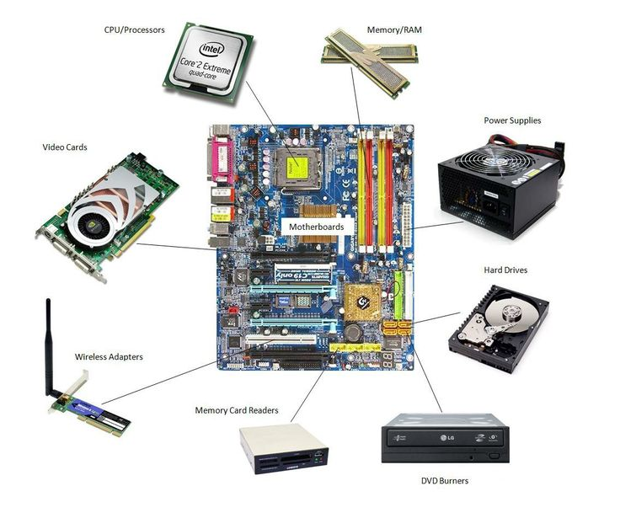

### ****7. Power On and Test the System****

With everything connected, it’s time to power up and test your build.

#### ****7.1 Turn on the PSU****

Before you power on the system, make sure the PSU is switched on. You should also check that all cables are securely connected to avoid any issues when starting up.

#### ****7.2 Test the System****

Press the power button on your case. The fans should start spinning, and you’ll likely see the motherboard’s logo or BIOS screen appear on the monitor. If everything is working properly, you can proceed to install an operating system, like Windows, and get started with your new computer.

**Conclusion**

Assembling a computer from scratch is a process that involves careful attention to detail, but with patience, it’s also a rewarding experience. From installing the CPU and thermal paste to mounting the motherboard and connecting all the components, each step plays an essential role in ensuring the system runs smoothly. By following these steps, you can build a computer that’s tailored to your needs and enjoy the satisfaction of knowing exactly how it all fits together.

# LAB  3

### ****Title: Understanding the Internal Structure of a Motherboard****

**Introduction**

Think of the motherboard as the central nervous system of a computer. It's the large, flat board inside the computer that connects and allows communication between all of the key components. Without the motherboard, the CPU, memory, and other components wouldn't be able to work together. The motherboard might look like a simple piece of hardware at first glance, but it’s packed with intricate parts that play a huge role in how well your computer performs. In this report, we'll explore the key components of the motherboard, understand their purpose, and see how they work together to make the computer function smoothly.

### ****1. Central Processing Unit (CPU) Socket****

#### ****Purpose and Role****

The CPU socket is where the brain of your computer—the CPU—sits. It connects the CPU to the motherboard and allows it to communicate with other components. The CPU does all the heavy lifting, running programs and performing calculations, so this socket is crucial for the computer to function.

#### ****Different Types of CPU Sockets****

Not all CPUs are the same, and neither are their sockets. The two main brands that manufacture CPUs are Intel and AMD, and each uses different types of sockets.

* **Intel Sockets (LGA)**: Intel uses a land grid array (LGA) socket, where the motherboard has pins, and the CPU has flat pads that make contact with them.
* **AMD Sockets (AM)**: AMD's sockets, known as AM sockets, have pins on the CPU that fit into the socket on the motherboard.

Each socket type is designed to fit specific CPUs, so the motherboard must be compatible with the CPU you're using.

### ****2. Chipset****

#### ****Purpose and Role****

The chipset on a motherboard serves as the traffic manager. It directs data between the CPU, RAM, storage devices, and peripherals like USB devices. It plays a key role in making sure that everything communicates smoothly.

* **Northbridge (older systems)**: The northbridge used to handle communication between the CPU, RAM, and GPU (Graphics Processing Unit). It’s responsible for the fast-moving parts of the system.
* **Southbridge**: This component manages slower tasks like input/output devices (USB ports, audio, network connections) and storage devices.

In modern systems, the functions of both the northbridge and southbridge have been combined into one unit, often called the Platform Controller Hub (PCH), making the design simpler and more efficient.

### ****3. Memory (RAM) Slots****

#### ****Purpose and Role****

RAM (Random Access Memory) is your computer's short-term memory. When you run a program, it's loaded into RAM because it’s faster to access than other forms of storage. The motherboard has slots that hold the RAM modules, allowing your computer to store and access data quickly while it's running.

#### ****Types of RAM****

The type of RAM a motherboard can support depends on its generation. There are several types of RAM commonly used today:

* **DDR3**: Older type of RAM, mostly found in older systems.
* **DDR4**: The most commonly used type in modern computers, offering better speed and efficiency than DDR3.
* **DDR5**: The newest, fastest generation of RAM, providing higher speeds and bandwidth for demanding tasks like gaming and video editing.

### ****4. Expansion Slots (PCI/PCIe)****

#### ****Purpose and Role****

Expansion slots are where you plug in additional components that expand the capabilities of your computer. For example, if you want to play high-end games, you'll need a graphics card (GPU), which goes into an expansion slot. These slots allow the components to communicate directly with the CPU and memory, which is important for performance.

#### ****Different Types of Expansion Slots****

* **PCIe x16**: This slot is used for high-speed components like graphics cards. It provides the bandwidth needed for the fast data transfers that a GPU requires.
* **PCIe x1**: Smaller expansion slots for things like network cards or sound cards.
* **PCI Slots**: The older, slower standard that has been mostly replaced by PCIe.

### ****5. Storage Interfaces****

#### ****Purpose and Role****

Storage interfaces are where you connect your hard drives (HDDs) or solid-state drives (SSDs) to the motherboard. These interfaces manage the flow of data between the storage device and the rest of the computer.

#### ****Types of Storage Interfaces****

* **SATA**: These ports are used for connecting traditional hard drives or SSDs. SATA is slower than newer interfaces but still common in many systems.
* **M.2**: A newer, faster interface used for SSDs. M.2 slots allow for blazing-fast data transfers, which is especially useful for tasks like video editing or gaming.
* **U.2**: Often used in enterprise environments, this is another high-speed interface for SSDs.

### ****6. Power Connectors****

#### ****Purpose and Role****

The power connectors on the motherboard are how the system gets its energy from the power supply unit (PSU). The motherboard has a few key connectors to ensure that everything gets the right amount of power.

* **24-pin ATX connector**: This is the main power connector that feeds the motherboard and most components.
* **8-pin CPU power connector**: This specific connector powers the CPU, ensuring it gets the necessary energy to function at full speed.

### ****7. BIOS/UEFI Chip****

#### ****Purpose and Role****

The BIOS (or UEFI) chip on the motherboard contains the firmware that allows the system to boot up and initialize hardware. It’s a small piece of software that runs as soon as you power on your computer and helps your system recognize all connected devices. While BIOS is becoming outdated, it’s being replaced by UEFI, which offers more advanced features and better compatibility.

### ****8. I/O Ports and Headers****

#### ****Purpose and Role****

The I/O ports on the back of the motherboard are the "ports" through which you connect external devices like USB drives, speakers, and monitors. These ports allow the computer to communicate with the outside world.

* **USB ports**: For connecting devices like keyboards, mice, and external drives.
* **Audio jacks**: For connecting speakers, microphones, or headphones.
* **Ethernet ports**: For connecting to wired networks.
* **Display ports**: HDMI, VGA, or DisplayPort to connect your monitor.

### ****9. Integrated Peripherals****

#### ****Purpose and Role****

Integrated peripherals are built-in components that add extra functionality to the motherboard. These are parts of the motherboard that handle specific tasks without needing additional cards.

* **Onboard audio**: Handles sound output and input without the need for a dedicated sound card.
* **Network Interface Controller (NIC)**: Provides the ability to connect to the internet via Ethernet.

Some motherboards even come with built-in Wi-Fi, Bluetooth, or additional controllers for special features.

### ****10. Cooling System Connectors****

#### ****Purpose and Role****

The cooling system connectors are where the fans and other cooling devices plug into the motherboard to keep everything cool. Without them, the computer would overheat, which could lead to system instability or permanent damage to components.

* **CPU_FAN**: The connector for the CPU cooling fan.
* **SYS_FAN**: General connectors for other fans in the case.

### ****11. Internal Buses****

#### ****Purpose and Role****

Internal buses are pathways that allow components on the motherboard to communicate with each other. These data paths are essential for transferring information quickly and efficiently between parts of the computer.

* **Front-Side Bus (FSB)**: A fast data path connecting the CPU to the chipset and memory.
* **Memory bus**: Carries data to and from the RAM.
* **PCIe lanes**: Used by expansion cards like GPUs for high-speed data transfer.

### ****12. CMOS Battery****

#### ****Purpose and Role****

The CMOS battery is a small battery on the motherboard that keeps the system settings stored, such as the time and date, even when the computer is turned off. Without it, the system would forget its settings every time the power is off.

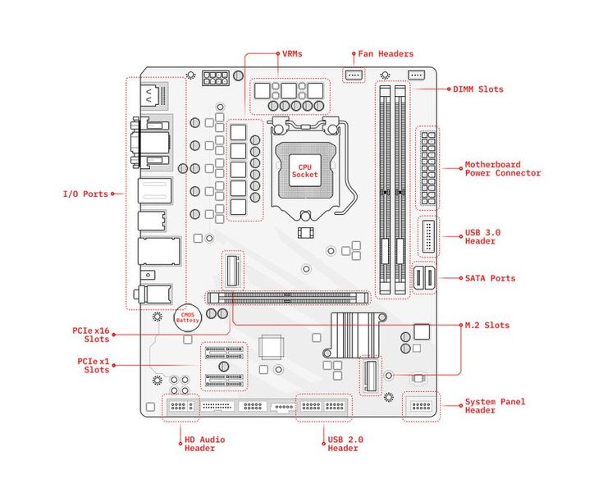

**Conclusion**

The motherboard is truly the heart of the computer, where all of the essential components come together to make the system work. From the CPU socket to the storage interfaces and expansion slots, each part plays an important role in ensuring that the system operates smoothly. Understanding the internal structure of the motherboard helps to appreciate just how much engineering goes into designing computers and how all the pieces fit together to create a functional system. Whether you’re building your own PC or just curious about how things work, knowing about the motherboard is an essential part of understanding how a computer functions.

LAB 4

# ****Overview of Microsoft Office Suite****

Microsoft Office is a collection of tools that millions of people use around the world for everything from creating documents and organizing data to delivering presentations and managing emails. Whether you're working on a big project, planning a team meeting, or just jotting down notes, Microsoft Office has an application for almost every need. This suite of programs has become an essential part of daily life for students, professionals, and businesses alike.

In this report, we'll dive into the core applications of Microsoft Office, explaining what they do, their main features, and how they can benefit you. Whether you're a beginner or an advanced user, these tools can help streamline tasks, improve productivity, and make collaboration easier.

## ****1. Main Applications in Microsoft Office****

Microsoft Office is made up of several different applications, each designed to serve a unique purpose. Below, we’ll take a closer look at some of the most widely used ones.

### ****1.1 Microsoft Word****

Microsoft Word is probably the most familiar application in the Office suite. It’s the go-to program for writing everything from simple notes to complex reports. Word provides a range of tools that help you format your text, organize ideas, and ensure your document looks professional.

#### ****Key Features of MS Word****

**Text Formatting**  
Word allows you to format text in any way you need. You can adjust the font type (like Arial or Times New Roman), change the font size, and even choose colors. Bold, italics, underline, and strikethrough options are there to highlight important points.

**Paragraph Formatting**  
You can align your text left, center, or right, or even justify it to make your document look neat. Additionally, Word lets you adjust line spacing, add bullet points or numbers, and indent text for a clean and organized layout.

**Styles and Themes**  
Word comes with predefined styles for headings, subheadings, and body text, making it easy to create documents with a consistent look. You can also apply a theme to the entire document to keep the design cohesive.

**Templates**  
Whether you’re creating a resume, writing a letter, or making a report, Word provides a variety of templates to help you get started. These templates have the formatting ready to go, so you don’t have to start from scratch.

**Insert Objects**  
Word lets you insert images, tables, charts, and even shapes to make your document more engaging. You can also include headers, footers, and hyperlinks to make the document more functional and interactive.

**Collaboration Tools**  
With Word, you can collaborate with others in real time, especially if you save your document on OneDrive or SharePoint. Features like Track Changes let you see what others have added or edited, making group work much easier.

**Spelling & Grammar Check**  
Word includes an automatic spelling and grammar checker that catches mistakes and offers suggestions. Plus, there’s a built-in thesaurus and translation tools to help you write better.

**Table of Contents**  
If your document is lengthy, Word can automatically generate a table of contents based on the headings you’ve included. This saves you time and ensures the structure is clear to your readers.

**Review and Editing Tools**  
Word has features like Compare and Merge, which allow you to compare different versions of the same document. You can also track changes made by others and decide whether to accept or reject them.

**Mail Merge**  
For creating personalized documents (like form letters or invitations), Word’s Mail Merge feature lets you pull data from a spreadsheet to automatically fill in names and addresses.

**Cloud Integration**  
Saving your work on OneDrive means you can access and edit your documents from anywhere, whether you're on your laptop, tablet, or phone.

**Accessibility Features**  
Word includes features like Read Aloud and Dictation to help users with different needs. The Accessibility Checker ensures your document is easy to read for everyone.

**Smart Lookup**  
With Smart Lookup, you can right-click on a word or phrase and get instant access to definitions, Wikipedia entries, or even web searches, helping you learn more without leaving the document.

#### ****Why MS Word is Beneficial****

Microsoft Word is not only powerful but incredibly easy to use. It helps you create polished, professional documents, whether you’re writing a letter, preparing a report, or even working on a thesis. The collaboration tools make it perfect for group work, while the cloud features allow you to keep your files safe and accessible from anywhere. Whether you're a student or a business professional, Word is an essential tool for creating high-quality text documents.

### ****1.2 Microsoft Excel****

Microsoft Excel is the application people turn to when they need to work with numbers, whether it's for budgeting, analyzing data, or creating charts. Excel is a spreadsheet program that helps you organize, manipulate, and visualize data.

#### ****Key Features of MS Excel****

**Data Organization**  
Excel organizes data into rows and columns, making it easy to sort and filter information. You can create complex datasets, track changes, and maintain organized records.

**Formulas and Functions**  
Excel is packed with built-in functions that let you perform mathematical and statistical operations. Whether you’re adding up totals with SUM or finding averages with AVERAGE, Excel can help you crunch numbers quickly and accurately.

**Charts and Graphs**  
If you want to present your data visually, Excel’s charting tools are incredibly useful. You can create bar charts, line graphs, pie charts, and more, helping your audience better understand the data trends.

**Pivot-tables**  
Pivot-tables are one of Excel’s most powerful tools. They allow you to summarize large data-sets in just a few clicks, helping you analyze and identify patterns quickly.

**Data Validation**  
This feature allows you to control what kind of data is entered into specific cells. For example, you can make sure users only enter dates or numbers, which helps prevent errors.

**Conditional Formatting**  
You can highlight cells that meet certain criteria, like values above a certain amount. This makes it easy to spot important information at a glance.

**Macros**  
If you often find yourself repeating tasks, Excel’s Macros can help you automate them. This feature records your actions and lets you play them back, saving you time.

**Collaboration Tools**  
Like Word, Excel also integrates with OneDrive, which makes real-time collaboration on spreadsheets possible. Multiple people can work on a file at the same time, making teamwork easier than ever.

**Security Features**  
Excel allows you to protect your files with passwords and offers data encryption to keep sensitive information safe.

#### ****Why MS Excel is Beneficial****

Excel is a must-have tool for anyone who works with numbers. It’s incredibly flexible and can be used for everything from simple budgeting to complex financial analysis. The charts and Pivot-tables make it easy to visualize data, while the automation features can save you hours of work. Whether you’re tracking expenses, analyzing sales trends, or managing large data-sets, Excel has you covered.

### ****1.3 Microsoft PowerPoint****

PowerPoint is the tool you use to create presentations. Whether you're pitching a business idea, delivering a lecture, or showing off a new product, PowerPoint makes it easy to organize your thoughts and engage your audience.

#### ****Key Features of MS PowerPoint****

**Slide Layouts**  
PowerPoint comes with a variety of slide layouts, which can help you structure your presentation in a clear and consistent way. There are title slides, content slides, and more, depending on the type of presentation you’re making.

**Design and Templates**  
You can choose from a range of built-in templates to give your slides a professional look. These templates save time and make sure your presentation is visually appealing.

**Animations and Transitions**  
PowerPoint lets you add animations to text and images, making your presentation more dynamic. Transitions between slides can also be customized for a smooth flow.

**Multimedia Integration**  
You can insert images, videos, and audio files to make your presentation more interactive and engaging. It’s easy to include web links and external content too.

**Presenter View**  
With Presenter View, you can see your notes and upcoming slides while presenting, which helps keep you on track and organized.

**Collaboration Tools**  
PowerPoint allows multiple users to work on the same presentation at the same time. This feature is especially useful for teams that need to collaborate on presentations in real time.

**Cloud Integration**  
PowerPoint integrates with OneDrive, making it easy to store, access, and share presentations from anywhere. You can work from any device with internet access, ensuring you always have your presentation ready.

#### ****Why MS PowerPoint is Beneficial****

PowerPoint is the go-to tool for creating presentations that are visually engaging and easy to follow. It offers a wide range of features to enhance your slides, from animations to multimedia integration, making it perfect for professional and educational settings.

### ****1.4 Microsoft Outlook****

Outlook is more than just an email tool—it's a comprehensive personal information manager that integrates email, calendar, tasks, and contacts all in one place.

#### ****Key Features of MS Outlook:****

**Email Management**  
Outlook helps you manage your emails efficiently. You can categorize and sort emails into folders, set up rules to automatically sort incoming messages, and track your emails with flags.

**Calendar Integration**  
Outlook's calendar makes scheduling meetings and events easy. You can send invites, set reminders, and view your schedule alongside your inbox.

**Task Management**  
Outlook’s task manager allows you to create to-do lists, assign tasks, and set deadlines. It’s a great way to stay organized and on top of your responsibilities.

**Contacts and Address Book**  
The contacts feature keeps all your email addresses, phone numbers, and other contact info in one place, so you can easily stay in touch with colleagues and clients.

**Collaboration**  
Outlook integrates seamlessly with Microsoft Teams and SharePoint, making it easier to schedule meetings, share files, and collaborate in real time.

#### ****Why MS Outlook is Beneficial****

Outlook is an all-in-one tool that helps you stay on top of your emails, calendar, and tasks. It’s great for managing communication and scheduling in both professional and personal life, and its integration with other Microsoft tools makes it even more powerful.

### ****1.5 Microsoft Teams****

Microsoft Teams is a collaboration hub that brings together chat, video meetings, file sharing, and project management in one platform.

#### ****Key Features of MS Teams****

**Team Communication**  
Teams allows you to message teammates, create channels for different projects, and keep all conversations organized. It’s perfect for remote work and group discussions.

**Video Conferencing**  
Teams supports high-quality video meetings, making it easy to connect with colleagues or clients, no matter where they are.

**File Sharing and Collaboration**  
Teams integrates with OneDrive, making file sharing and collaborative work on documents a breeze.

#### ****Why MS Teams is Beneficial****

Teams is perfect for remote work and team collaboration. Whether you're chatting, meeting, or sharing files, Teams makes it easy to stay connected and productive.

Microsoft Office has become an integral part of modern work and learning. From creating documents and analyzing data to delivering presentations and managing emails, its diverse applications offer essential tools for productivity and collaboration. Understanding these tools can not only make your daily tasks easier but also help you maximize your efficiency in both academic and professional settings.

LAB 5

## ****1. Mail Merge: Personalizing Documents****

### ****What is Mail Merge?****

Mail Merge is an incredibly helpful tool in Microsoft Word that automates the process of creating personalized documents like letters, labels, and envelopes. Instead of manually typing each letter for every recipient, Mail Merge lets you use a list (usually in Excel) and inserts personalized details into a template automatically. Imagine sending a letter to hundreds of people, each with their name, address, and specific details—Mail Merge makes this task much quicker and more efficient.

### ****How Does Mail Merge Work?****

#### ****Step 1: Start Mail Merge****

To begin, you need to choose the type of document you're creating, such as a letter, envelope, or label. Here’s how to do it:

1. In Word, go to the **Mailings** tab.
2. Click **Start Mail Merge** and select the document type (for example, Letters).

#### ****Step 2: Select Recipients****

This step is where you choose the list of names and addresses (or any other data) you want to merge into your document. The data can be stored in an Excel file, CSV file, or even a contact list from Outlook.

1. Click **Select Recipients** and choose **Use an Existing List**.
2. Browse for the Excel file or another data source that contains your recipient information.

#### ****Step 3: Insert Merge Fields****

Once your data is linked, you’ll add placeholders (called Merge Fields) in your document where the personalized details will go. For example, you might want to insert a recipient’s name or address.

1. Click **Insert Merge Field**.
2. Choose the fields you want to add, such as "First Name" or "Address" from your list.

#### ****Step 4: Finish & Merge****

Finally, once your document is ready with the placeholders, you can merge the information. Word will create a new document where each piece of data (like a name or address) is inserted automatically into the right spots.

1. Click **Finish & Merge**.
2. Select **Print Documents** or **Create New Document**. The choice depends on whether you want to print your personalized letters or just create a new file.

### ****Mail Merge Tips:****

* **Data Organization:** Make sure your Excel sheet is well-organized, with each column representing a piece of data (like name, address, etc.) and each row representing a recipient.
* **Proofread First:** Always check the first few merged documents to ensure everything is formatted and merged correctly.

## ****2. Table of Contents (TOC): Navigating Your Document****

### ****What is a Table of Contents?****

A Table of Contents (TOC) is an automatically generated list of headings and subheadings from your document. It acts as a roadmap, allowing readers to jump to the sections they’re interested in. It's especially useful in long reports, research papers, or books.

### ****How to Create a Table of Contents****

#### ****Step 1: Apply Heading Styles****

Before you can generate a TOC, you need to mark the different sections in your document. The easiest way to do this is by using Heading Styles.

1. Highlight the text you want to designate as a title (e.g., Chapter 1, Introduction).
2. In the **Home** tab, apply the appropriate heading style (Heading 1 for main titles, Heading 2 for subsections, etc.).

#### ****Step 2: Insert the Table of Contents****

Now that you’ve applied the headings, you can insert the TOC.

1. Go to the **References** tab.
2. Click **Table of Contents**, and choose a style from the options.
3. Word will create a TOC that lists all your headings and their corresponding page numbers.

#### ****Step 3: Update the Table of Contents****

If you make any changes to your document, like adding or removing headings, you’ll need to update the TOC.

1. Right-click on the TOC.
2. Click **Update Field**, and choose whether to update just the page numbers or the entire table.

### ****TOC Tips:****

* **Use Consistent Headings:** Always use the same Heading styles for similar sections (Heading 1 for chapters, Heading 2 for subsections) to keep the TOC organized.
* **Update Regularly:** If you change the content of your document, don’t forget to update the TOC.

## ****3. Section Breaks: Organizing Document Layouts****

### ****What Are Section Breaks?****

Section Breaks are useful when you need to change the layout or formatting of part of your document. For example, you might want to have one part of your document in portrait orientation and another in landscape. Section Breaks allow you to do this without affecting the entire document.

### ****How to Insert Section Breaks****

1. Place your cursor where you want to start a new section.
2. Go to the **Layout** tab, click **Breaks**, and choose the type of Section Break you need. There are several types:
   * **Next Page:** Starts a new section on the next page.
   * **Continuous:** Starts a new section on the same page.
   * **Odd/Even Page:** Starts a new section on the next odd or even page.

### ****Why Use Section Breaks?****

* **Page Numbering:** Use Section Breaks to apply different page numbering styles (Roman numerals for intro pages and Arabic numbers for the body of the document).
* **Layout Flexibility:** You might need to switch from portrait to landscape for a specific page (like a wide table), which Section Breaks allow.

### ****Section Break Tips:****

* **Headers and Footers:** When using multiple sections, you can choose whether to keep the same header/footer for all sections or have different ones for each. Just make sure to turn off **Link to Previous** if you need a different header or footer.

## ****4. References: Citing Sources****

### ****Why Are References Important?****

Adding citations, footnotes, and a bibliography to your document is essential when you’re using sources of information. It helps you give credit to the original authors and allows others to verify the sources of your information.

### ****How to Add Citations****

1. Go to the **References** tab.
2. Click **Insert Citation** and choose **Add New Source**.
3. Fill in the source details (like author name, title, year of publication).

#### ****Adding Footnotes and Endnotes****

Footnotes are commonly used for additional explanations at the bottom of the page, and endnotes are similar but appear at the end of the document. To add them:

1. Click **Insert Footnote** or **Insert Endnote**.
2. Word will automatically number them for you and place them at the bottom of the page (or at the end).

### ****Managing Citations:****

* You can store and organize all your references in Word’s **Manage Sources** tool, making it easier to reuse them across different documents.

### ****References Tips:****

* **Use the Correct Style:** Ensure you're using the right citation style (APA, MLA, Chicago) by choosing it under the **Style** menu in the **References** tab.
* **Source Management:** The **Source Manager** feature allows you to organize and store your citations, making it easier to manage multiple sources across different documents.

## ****5. Headers and Footers: Professionalizing Your Document****

### ****What Are Headers and Footers?****

Headers and Footers are areas at the top and bottom of each page in your document. They’re used to add information that appears on every page, such as page numbers, the document title, or author name.

### ****How to Add Headers and Footers****

1. Go to the **Insert** tab and click **Header** or **Footer**.
2. Select a style, and add content such as text, page numbers, or images.

#### ****Different Headers/Footers for Different Sections****

You can have different headers or footers in different parts of your document (e.g., the title page might have no header, but the body pages could have the document title).

1. To unlink headers/footers from previous sections, double-click the header or footer and turn off **Link to Previous**.

#### ****Page Numbers****

To add page numbers, just go to the **Insert** tab and click **Page Number**. You can choose the location (top or bottom) and style.

### ****Tips for Headers and Footers:****

* **Multiple Sections:** When your document has different sections (like an introduction and body), make sure to check the **Link to Previous** box when you want the same header/footer across sections, and uncheck it if you want them to differ.
* **Keep It Simple:** Don’t overcrowd the header or footer with too much information—keep it clean and professional.

## ****Conclusion: Making the Most of Word’s Features****

Microsoft Word is full of powerful tools that can help you create well-organized, professional, and polished documents. Whether you’re creating a report, writing a book, or managing a long project, understanding how to use Mail Merge, Table of Contents, Section Breaks, References, and Headers/Footers will save you time and enhance your work. By mastering these tools, you’ll ensure that your documents are both efficient and impactful.

**LAB 6**

### 1. ****Mendeley (Reference Management and Citation Tool)****

**Purpose:**  
Mendeley is like a personal assistant for your research papers. It helps you organize your sources, generate citations, and even create a bibliography with just a few clicks. Whether you’re working on an essay, a research paper, or a thesis, Mendeley is a great tool to keep your sources organized and save time on formatting.

**Features:**

**Reference Management:**  
With Mendeley, you can easily import research papers from popular academic databases like Google Scholar, JSTOR, and PubMed. It’s like having a digital filing cabinet that keeps all your references in one place.

**Citations:**  
Mendeley takes care of the tedious task of formatting citations for you. Whether you need APA, MLA, or Chicago style, Mendeley generates citations in the style you choose, so you don’t have to worry about punctuation or formatting.

**Bibliography Generation:**  
Once you’ve inserted your citations, Mendeley can generate a complete bibliography at the end of your paper with just one click. No more manually compiling and formatting references.

**Collaboration:**  
Working with others on a research project? Mendeley makes it easy to collaborate by letting you share your research, references, and documents with your team. Everyone can stay on the same page and access shared resources.

**Steps for Using Mendeley:**

**Install Mendeley:**  
First, download Mendeley Desktop from their website and install it on your computer. It’s available for Windows, Mac, and Linux, so you can use it no matter your system.

**Add Documents:**  
You can add documents to Mendeley by dragging and dropping PDFs into the program. Mendeley will automatically extract citation details like title, author, and journal name, making it easy to keep track of everything.

**Use Mendeley with Word:**  
Install the Mendeley plugin for Word to start adding citations and generating bibliographies directly within your document.

**Insert Citations:**  
When you need to add a citation, just click on the “References” tab in Word, then click "Insert Citation." You’ll be able to search for the reference from your Mendeley library, and it will insert the correct citation style into your document automatically.

**Generate Bibliography:**  
Once you've finished inserting your citations, click "Insert Bibliography," and Mendeley will create a well-formatted bibliography in seconds.

### 2. ****Grammarly (Grammar and Writing Assistance)****

**Purpose:**  
Grammarly is your go-to writing assistant for checking grammar, spelling, punctuation, and even improving the style of your writing. Whether you're drafting an email, writing an essay, or putting together a report, Grammarly helps you polish your text and ensures that it’s error-free.

**Features:**

**Grammar Check:**  
Grammarly catches all the little grammar and punctuation mistakes you might miss, like misplaced commas, sentence fragments, or subject-verb agreement issues. It also checks for spelling errors, so you don’t have to worry about typos.

**Writing Style:**  
Grammarly offers suggestions to improve your writing style. It helps you make your sentences clearer and more concise, and it can even suggest better word choices.

**Plagiarism Detection:**  
If you’re worried about unintentional plagiarism, Grammarly has a plagiarism checker that compares your text against millions of sources online. It makes sure your work is original and properly cited.

**Tone Detection:**  
Want to know if your writing sounds too formal, casual, confident, or uncertain? Grammarly analyzes the tone of your text, so you can adjust it to fit the context of your writing.

**Steps for Using Grammarly:**

**Install Grammarly:**  
You can download the Grammarly browser extension or use the desktop app. The browser extension checks your writing in real-time while you’re composing emails or social media posts, while the desktop app works great for longer documents.

**Use Grammarly in Word:**  
Once installed, Grammarly integrates seamlessly with Microsoft Word. It appears as a sidebar within Word, offering suggestions and corrections as you write. No more second-guessing grammar rules!

**Proofread:**  
After Grammarly checks your document, you’ll see all the suggestions in the sidebar. You can accept or ignore each one based on your preference—Grammarly also gives explanations, so you can learn from your mistakes.

### 3. ****PDF Element (PDF to Word Conversion Tool)****

**Purpose:**  
PDF Element is a handy tool for editing PDFs and converting them to Word, Excel, PowerPoint, and more. If you’ve ever tried to edit a PDF and found it impossible, PDF Element solves that problem by letting you modify text, images, and even scanned documents.

**Features:**

**PDF to Word Conversion:**  
Need to edit a PDF but don’t have the original Word file? PDF Element lets you convert PDFs into fully editable Word documents while preserving the formatting, so you don’t have to start from scratch.

**Editing PDFs:**  
You can directly edit PDFs by adding or deleting text, inserting images, or even rearranging pages. It’s a flexible tool that makes working with PDFs much easier.

**Form Filling:**  
If you’re dealing with a fillable PDF form, PDF Element lets you add your information directly into the form fields. It recognizes the form fields, so you can quickly complete and save your forms.

**OCR (Optical Character Recognition):**  
PDF Element’s OCR technology allows you to convert scanned documents into editable text. So, if you have a scanned image of a document, you can extract the text and work with it as you would any normal document.

**Steps for Using PDF Element:**

**Install PDF Element:**  
Download PDF Element from the Wondershare website and install it on your computer. Once you’ve set it up, you’re ready to start working with your PDFs.

**Convert PDF to Word:**  
To convert a PDF to Word, just open the document in PDF Element, click the “Convert” button, and choose “To Word.” The tool will preserve the original formatting and make the document fully editable.

**Edit PDF:**  
Want to change something in a PDF? Just click the "Edit" tab, and you can modify the text, add images, or make other changes as needed.

**OCR:**  
If your PDF is scanned, use the OCR feature to convert the text into editable form. Just click “OCR,” choose the language, and PDF Element will extract the text so you can edit it.

### 4. ****Automating Repetitive Tasks with Macros in Word****

**Purpose:**  
Macros are a great way to save time on repetitive tasks in Microsoft Word. If you often find yourself doing the same thing over and over (like applying the same formatting or inserting headers), macros can automate these tasks with just a click or a shortcut.

**Steps to Create a Macro:**

**Record a Macro:**

* + In Word, go to **View** > **Macros** > **Record Macro**.
  + Name your macro and assign a shortcut key (optional).
  + Perform the task you want to automate, such as formatting text, inserting headers, or applying a specific style.

**Stop Recording:**  
After completing the task, go to **View** > **Macros** > **Stop Recording** to save your macro.

**Run a Macro:**  
To run your macro, use the shortcut key you assigned, or go to **View** > **Macros** > **View Macros** and select your macro. Click **Run**, and the task will be automated for you.

### 5. ****Referencing Tools for Citations, Footnotes, and Endnotes****

**Purpose:**  
When writing academic papers, it's crucial to insert citations, footnotes, and endnotes properly. Microsoft Word has built-in tools that make this process much easier, ensuring that your document is professionally formatted and correctly referenced.

**Steps for Using Referencing Tools:**

**Insert Citations:**

* 1. Go to the **References** tab, then click **Citations & Bibliography**.
  2. Click **Insert Citation** and select a source from your library, or add a new one.
  3. Word will automatically format the citation in the correct style (e.g., APA, MLA).

**Insert Footnotes/Endnotes:**

* 1. To insert a footnote, go to **References** > **Insert Footnote**. Word will add the footnote at the bottom of the page.
  2. To insert an endnote, click **Insert Endnote**. Endnotes appear at the end of your document or section.

**Manage Sources:**  
Use the **Manage Sources** button to keep track of your citations for future use. You can edit and update sources, ensuring your references stay consistent.

With these tools and techniques, you can streamline your writing process and enhance your productivity. Mendeley helps you manage references, Grammarly ensures your writing is polished, PDF Element makes editing PDFs a breeze, and macros automate repetitive tasks. Together, these tools will improve the quality and efficiency of your work.

## Practical Application of MS Word Features Conducted in Lab 07

### ****Getting Started with Microsoft Word: Home Menu Overview****

Microsoft Word is an essential tool for students, professionals, and anyone who needs to create documents. Whether you're writing a lab report, essay, or just creating a list, Word offers a wide range of features to help you format and organize your work efficiently. By becoming familiar with the **Home Menu** and its different sections, you’ll find that Word becomes a lot easier to use.

#### ****Creating a New Document****

When you first open Microsoft Word, you usually start with a blank document. To create a new document, click on the **New** option, or if you’re comfortable with shortcuts, simply press Ctrl + N. This opens a new, clean slate for you to start working on your project. You can also choose from various templates, like resumes, reports, or brochures, to make your document look more polished from the start.

#### ****Opening an Existing Document****

If you're continuing work from a previous session, you can easily open an existing document. Use the **Open** function (or press Ctrl + O) to locate the file you’ve been working on. It’s a quick way to pick up where you left off, especially if you’ve been working on multiple drafts or projects.

#### ****Managing Document Information and Privacy****

In the **Info** section, you can view important details about your document, such as the author, word count, and the last time it was modified. This can help you keep track of your work. Another key feature here is the privacy settings, which let you see who has access to your document, especially when collaborating with others. It’s important to check these settings to ensure your document is secure.

#### ****Saving and Printing Documents****

One of the best practices when working in Word is to save your progress regularly.

**Save (Ctrl + S)**:  
It’s easy to forget to save your work, but pressing Ctrl + S regularly will make sure you don’t lose anything. Word will keep track of the changes, and it’s always a good habit to save before you take a break.

**Save As (Ctrl + Shift + S)**:  
If you want to give your document a new name or save it in a different format (like a PDF), use the **Save As** function. This is especially useful when you need to send a copy of your work to someone or need a specific file type for submission.

**Print (Ctrl + P)**:  
Once your document is ready to go, use the **Print** function (Ctrl + P) to print it out. You can adjust print settings like page orientation and the number of copies, which is helpful for printing reports or assignments.

#### ****Sharing and Exporting Documents****

**Share**:  
If you need to collaborate with someone or share your document, the **Share** button lets you send it through email, provide a link, or even share access for live editing. You can control whether the person you're sharing with can edit or only view the document.

**Export**:  
When you need your document to be in a specific format—like a PDF for submitting assignments or sending reports—you can use the **Export** option. This ensures your document looks just the way you want it, regardless of the device or program someone else is using to view it.

#### ****Closing a Document****

When you’re done working, you can simply close the document by clicking the **Close** button. If you haven’t saved your work, Word will remind you to save before you exit. If you haven’t named your document yet, Word will automatically suggest a name for you, which can save time.

### ****Exploring Microsoft Word's Home Menu Groups****

The **Home** tab is where you’ll spend most of your time in Microsoft Word. It’s divided into different groups that organize all the tools you need. Let’s take a closer look at these groups and how they help you format and edit your documents.

#### ****Clipboard Group****

The **Clipboard** group is where you'll find tools for cutting, copying, and pasting text. These are the basics of editing, and they help you move or duplicate content within your document.

**Cut (Ctrl + X)**:  
Cutting removes text from one place in your document and allows you to paste it elsewhere. This is great for reorganizing sections or moving content to a different spot.

**Copy (Ctrl + C)**:  
Copying keeps the original text in place while making a duplicate of it elsewhere. This is useful when you want to reuse content without changing its original location.

**Paste (Ctrl + V)**:  
After cutting or copying text, use **Paste** to insert it where you want it. You can choose whether to keep the original formatting or apply new styles.

**Format Painter**:  
This little tool helps you copy the formatting from one part of your document and apply it to another. For example, if you’ve made a heading bold and italic, you can use the **Format Painter** to quickly apply those styles to another section of your document without doing it manually.

#### ****Font Group****

The **Font** group is where you can change the appearance of your text. This helps you make certain parts of your document stand out or look more polished.

**Clear Formatting**:  
If you’ve applied too many styles or if something looks off, the **Clear Formatting** option resets your text to its default style, making it easier to start fresh.

**Bold (Ctrl + B)**, **Underline (Ctrl + U)**, and **Italic (Ctrl + I)**:  
These are the basic ways to emphasize your text. Use **Bold** for important words, **Underline** for titles or headings, and **Italic** for emphasis or to highlight foreign words or book titles.

**Font Style and Size**:  
You can change the font style and size to fit the mood of your document. For example, Times New Roman is often used for formal reports, while a playful font might be used for invitations or casual documents.

**Strikethrough**:  
If you need to show that something should be removed or crossed out, use the **Strikethrough** function. This is especially useful when editing or marking text as deleted.

**Superscript and Subscript**:  
For scientific or mathematical documents, you may need to use superscript (like ²) or subscript (like H₂O). These features let you position text above or below the regular line of text.

### ****Formatting Paragraphs and Lists****

The **Paragraph** group offers tools for organizing and aligning your text in different ways. These are particularly useful when you want your content to be clear and well-structured.

#### ****Alignment****:

Alignment controls how text appears on the page. You can align text to the left, center, right, or justify it (where the text is evenly spaced across the page).

**Left Alignment (Ctrl + L)**:  
This is the most common alignment, where the text starts at the left margin and ends in a ragged right edge. This is standard for most written content.

**Centering (Ctrl + E)**:  
Center alignment is often used for titles and headings, giving them a more formal or balanced look in the center of the page.

**Right Alignment (Ctrl + R)**:  
Right alignment can be useful for specific formatting, such as aligning dates or page numbers at the end of a line.

**Justified (Ctrl + J)**:  
Justified text stretches the content to fill the entire width of the page, creating neat blocks of text with even edges on both sides. This is often used in professional documents like newspapers and books.

#### ****Bullets and Numbering****:

Lists are a great way to organize information clearly. Word offers two main types of lists:

**Bulleted Lists**:  
Bulleted lists are useful for when the order doesn’t matter, like listing ingredients or steps in a process.

**Numbered Lists**:  
Use numbered lists when the order is important, such as outlining a series of steps to follow or ranking items.

#### ****Line Spacing****:

Line spacing adjusts the amount of space between lines of text. If you’re working on an academic paper, you might need to use double spacing, which is easier to read and allows space for comments. You can also adjust spacing to single or 1.5 lines, depending on your needs.

### ****Editing and Organizing Your Document****

Editing tools in Word help you quickly make changes and find exactly what you're looking for.

**Find (Ctrl + F)**:  
If you need to locate a word or phrase in a long document, the **Find** function makes it easy. Just type the word you’re looking for, and Word will highlight all instances in the text.

**Replace (Ctrl + H)**:  
The **Replace** function lets you change one word or phrase for another throughout the entire document. This is useful if you’ve made an error or need to update information across your document.

**Select (Ctrl + A)**:  
The **Select All** command highlights the entire document, making it easy to apply formatting changes to everything at once.

### ****Inserting Visual Elements****

To make your document more engaging, you can add various elements like images, charts, or even videos.

**Headers and Footers**:  
Headers and footers are perfect for adding document titles, page numbers, or author information at the top or bottom of every page.

**Cover Pages**:  
Word offers a range of professional-looking cover pages that you can use to give your document a polished look right from the start.

**Images and Graphics**:  
You can insert pictures and other graphics into your document to make it more visually appealing. Whether it's a logo for a report or a photo for a presentation, images help break up text and make your document more dynamic.

**Online Videos**:  
Adding online videos (from sites like YouTube) can be a powerful way to enhance your content, especially if you're creating a report or presentation that includes multimedia elements.

|  |  |  |  |  |
| --- | --- | --- | --- | --- |
| Student Details | | | | |
| Roll # | Name | Class | section | marks |
|  |  |  |  |  |
| 1. | kinza | ict | y | 997 |
| 2. |  |  |  |  |
| 3. |  |  |  |  |
| 4. |  |  |  |  |

**THIRD Group**à**Paragraph**

• Left Alignmentàctrl + L

• Right Alignmentàctrl + R

• centeredàctrl + E

• justifiedàctrl + J

**Alignment :**

it is difficult to do but its ok as we can do it and I wo should remember to do our work on time and with extra efforts and fully concentration . Lab work is really very exciting and entertaining.

**Bullets :**

• Left Alignmentàctrl + L

• Right Alignmentàctrl + R

• centeredàctrl + E

• justifiedàctrl + J

**Numbering :**

1. tree

2. grass

3. fruits

**Sorting :**

**Drum**

**Guitar**

**Piano**

Line Spacing :

**Try try again till you succeed**

**You are the one**

Editing :

1. find

2. replace

3. select

|  |  |  |  |  |  |  |
| --- | --- | --- | --- | --- | --- | --- |
| December | | | | | | |
| M | T | W | T | F | S | S |
|  |  |  |  |  |  | 1 |
| 2 | 3 | 4 | 5 | 6 | 7 | 8 |
| 9 | 10 | 11 | 12 | 13 | 14 | 15 |
| 16 | 17 | 18 | 19 | 20 | 21 | 22 |
| 23 | 24 | 25 | 26 | 27 | 28 | 29 |
| 30 | 31 |  |  |  |  |  |
|  |  |  |  |  |  |  |

../Pictures/Saved%20Pictures/

[../Pictures/Saved%20Pictures/](https://d.docs.live.net/b2ea8cb59c64e86a/Pictures/Saved%20Pictures/)

\

​

#December à bookmark link

fruits ​à cross reference

fruits ​

**for random paragraph insert**

​=rand(n)

Video provides a powerful way to help you prove your point. When you click Online Video, you can paste in the embed code for the video you want to add. You can also type a keyword to search online for the video that best fits your document.

To make your document look professionally produced, Word provides header, footer, cover page, and text box designs that complement each other. For example, you can add a matching cover page, header, and sidebar. Click Insert and then choose the elements you want from the different galleries.

​